**PROGRAM [1]:**

import random

class TicTacToe:

def __init__(self):

self.board = [['-' for _ in range(3)] for _ in range(3)]

def get_random_first_player(self):

return random.choice(['X', 'O'])

def fix_spot(self, row, col, player):

self.board[row][col] = player

def is_player_win(self, player):

n = len(self.board)

for i in range(n):

if all(self.board[i][j] == player for j in range(n)) or all(self.board[j][i] == player for j in range(n)):

return True

if all(self.board[i][i] == player for i in range(n)) or all(self.board[i][n - 1 - i] == player for i in range(n)):

return True

return False

def is_board_filled(self):

return all(item != '-' for row in self.board for item in row)

def swap_player_turn(self, player):

return 'X' if player == 'O' else 'O'

def show_board(self):

for row in self.board:

print(*row)

def start(self):

**OUTPUT [1]:**

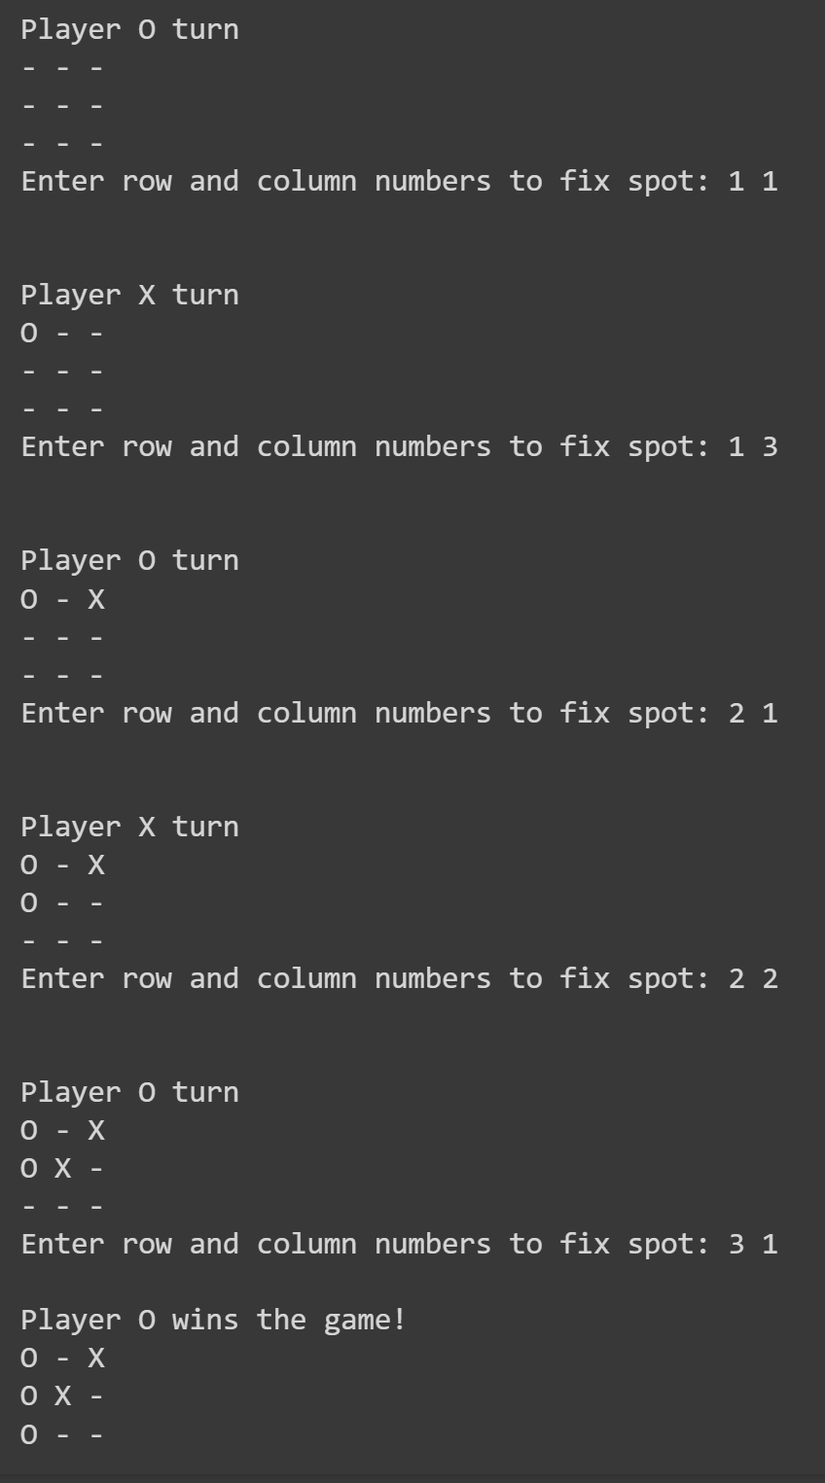

self.get_random_first_player()

player = 'X' if self.get_random_first_player() == 'X' else 'O'

while True:

print(f"Player {player} turn")

self.show_board()

row, col = map(int, input("Enter row and column numbers to fix spot: ").split())

print()

self.fix_spot(row - 1, col - 1, player)

if self.is_player_win(player):

print(f"Player {player} wins the game!")

break

if self.is_board_filled():

print("Match Draw!")

break

player = self.swap_player_turn(player)

print()

self.show_board()

tic_tac_toe = TicTacToe()

tic_tac_toe.start()